FOR IMMEDATE RELEASE
New Color Expands Decorative Ceiling Options
[170-word and 75-word versions]
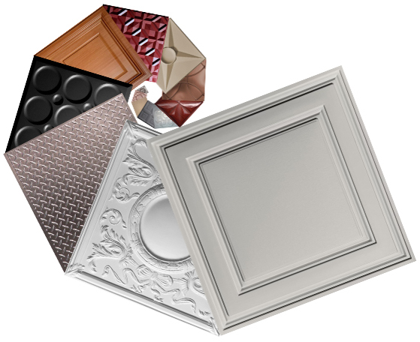
A new color, “Stone” (shown on top), joins Ceilume’s growing family of decorative thermoformed ceiling colors, styles, and finishes.
[170 words]
GRATON, CA, 2019-March 12 -- Ceilume has announced a new color of thermoformed decorative ceiling and wall panels and tiles, “Stone,” a light neutral grey tone. Stone was created in response to designers’ frequent requests for a neutral tone option.
The addition of Stone brings to seven the total number of opaque color choices, along with White, Sand, Latte, Merlot, Black, and the Random Gray made with 100% recycled content. In addition, there are three light-transmitting options (Clear, Frosted, and Translucent), three metallic finishes (Bronze, Copper, and Tin) and three wood faux finishes (Sandalwood, Caramel Wood, and Cherry Wood). Custom colors are also available.
Ceilume ceiling products offer low maintenance, easy cleaning, and long service life. They are impervious to moisture, do not support mold growth, are Greenguard Gold certified, and are reusable as well as fully recyclable. Panels for suspended ceilings offer excellent acoustics; because of their fire drop-out feature, they can be installed below sprinkler heads, concealing the fire protection system while still leaving it fully functional.
For more information, visit www.ceilume.com/pro.
[75 words]
GRATON, CA, YEAR-MO-DY -- Ceilume announces a new color of thermoformed decorative ceiling and wall panels and tiles, “Stone,” a light neutral grey tone. The addition of Stone brings to seven the total number of opaque color choices, along with three light-transmitting options, three metallic finishes, and three wood faux finishes. Custom colors are also available. Ceilume ceiling panels are available in 39 styles that offer acoustic performance, low maintenance, easy cleaning, and long service life.
For more information, visit www.ceilume.com/pro.
- - -
About Ceilume: Ceilume is the leading manufacturer of thermoformed ceiling and wall tiles and panels. The company’s roots go back to when “Mid-Century was Modern” and the pioneers of modular ceilings. The family-owned business is located in California’s wine country and occupies a historic apple-packing warehouse. With an eye on the future, Ceilume’s research and development continues to improve interior finish systems to meet changing environmental, performance, and aesthetic needs. For more information, see www.ceilume.com/pro.

High Resolution Photos: www.ceilume.com/pro/press.cfm

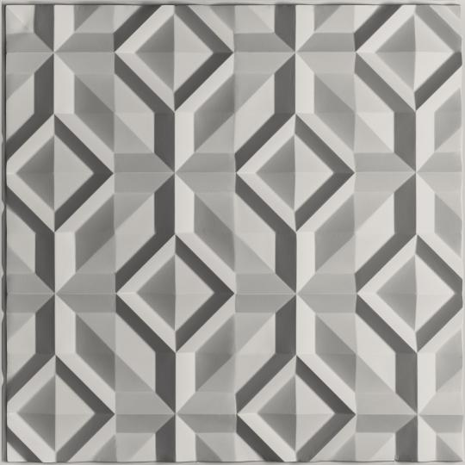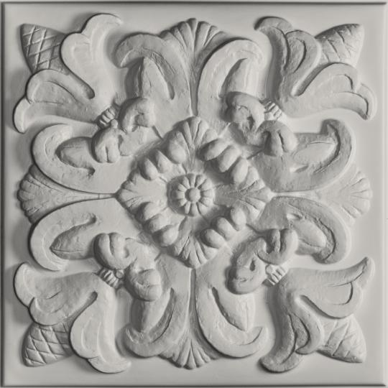
Stone-colored panels and tiles can convey a very contemporary sensibility, or evoke the ornate plaster ceilings of centuries past, depending on the three-dimensional style chosen. Ceilume’s Doric style is on left and Florentine is on right.
###

