FOR IMMEDATE RELEASE
Product News: Tests Compare Stain Resistance of Ceiling Panels
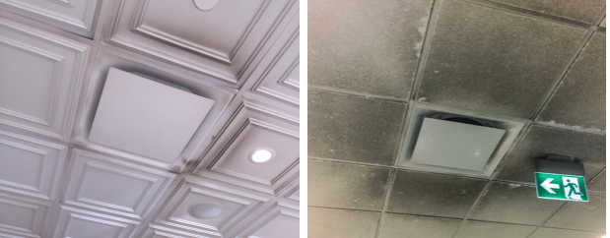
Left: Commonly used mineral fiber acoustic ceiling panels are easily disfigured and difficult to clean. Right: Recent testing demonstrates that, in contrast, thermoformed acoustic ceiling panels from Ceilume are highly stain resistant and grime like that on these panels can be removed with simple washing. Photo Credit: Ceilume

GRATON, CA, 2019-October-07 -- In this dirty world, good looks are not enough. Interior finishes often “ugly out” before they wear out. Many acoustic ceiling panels, for example, are difficult to clean and end up landfilled when they become unsightly. In contrast, ceiling panels that are stain-resistant and cleanable offer significant advantages in sustainability, economics, and life-cycle performance.

Ceilings are the part of a room in the least physical contact with occupants; yet they are exposed to dirt, grime, and stains from a variety of sources. Air currents from diffusers or ordinary convection carry dust, soot, and aerosols onto ceilings. Everyday substances splash, squirt, or spray upwards. Water from leaks, spills, and condensation cause stains and mold on common mineral fiber acoustic ceilings. Panels in suspended ceilings can also get dirty when handled for maintenance access above the ceiling. Despite this, reliable data on ceiling stainability and cleanability has been difficult to find.
With this problem in mind, the makers of Ceilume ceiling panels embarked on a program of third-party laboratory testing to compare the performance of widely used mineral fiber acoustic ceiling panels with that of Ceilume’s thermoformed acoustic ceiling panels.
METHODOLOGY*
Tests were performed according industry standard ASTM D1308 – Effect of Household Chemicals on Clear and Pigmented Organic Finishes and used 14 common staining agents including coffee, red wine, yellow mustard, ketchup, vegetable oil, bleach, povidone iodine, hydrogen peroxide, light machine oil, baking soda solution, vinegar, two types of swimming pool chlorine, and permanent marker. The laboratory compared one of the most widely used white mineral fiber panels against four colors of thermoformed rigid vinyl panels made by Ceilume.
Each staining agent was placed on a specimen panel and allowed to sit overnight. After being cleaned in accordance with the standard, specimens were examined visually, photographed, and findings summarized in the table accompanying this report.
RESULTS*
Mineral fiber panels showed “significant stains” from all the food products, povidone iodine, calcium hypochlorite, and light machine oil. They had faint stains from bleach and one of the chloride products. The only staining agent they resisted was hydrogen peroxide.
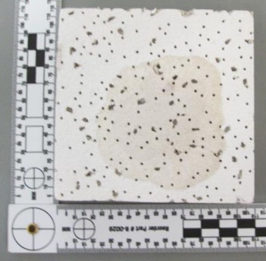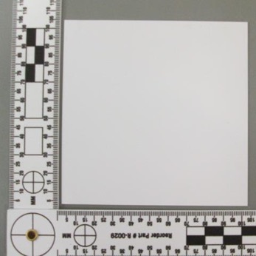
Left: Mineral fiber acoustical panels were disfigured by almost all other staining agents tested, including this specimen tested with red wine. Right: Ceilume’s thermoformed acoustic panels, in contrast, were highly resistant all but a few of the agents tested. Photo Credit: National Testing Systems.
In contrast, thermoformed acoustic ceiling panels proved highly stain-resistant with either no stains or only faint stains from all the agents tested. Permanent marker is the only exception to this observation as it stained all specimens. White showed no staining with any of the 13 other substances. Latte had only “very faint” stains from baking soda, coffee, and bleach; the laboratory noted these were, “very ‘faint’ and… appear as very slight discoloration of the surface where the substance was applied. They are very difficult to notice at first glance, and require an angled view under lighting to be seen.” Faux metal and wood finishes resisted everything except three harsh chemical solutions: bleach, hydrogen peroxide, and calcium hypochlorite.
DISCUSSION*
Mineral fiber panels typically have porous or fissured surfaces that are vital to their acoustic performance yet provide locations through which stains can enter into a panel and become difficult to dislodge. Most mineral fiber panels can be damaged by water or liquid, so there is no effective way to wash them. Further, their edges and corners are fragile and prone to damage when panels are handled or removed for cleaning.
Ceilume panels are made from rigid vinyl that is impervious to moisture and easily cleaned, factors that make them acceptable for use in hygienic environments such as over food handling and healthcare areas. They can be cleaned by brushing, vacuuming, or with water or common household cleaners. They are durable enough to be taken down, cleaned, and replaced without damage.
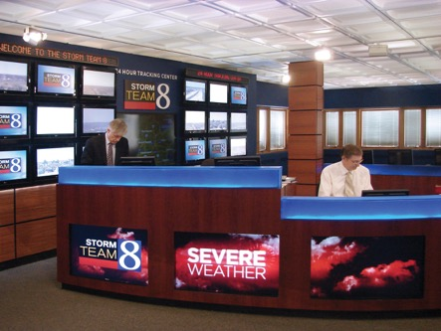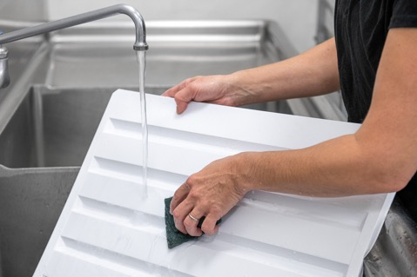
Left: The Ceilume thermoformed acoustic ceiling panels in this television station have been in use for more than a decade and, according to the station’s operations director, are holding up well and “look really good.” The panels’ stain resistance and washability has been a factor in their longevity. Photo Credit: WOOD-TV
Right: Thermoformed acoustic ceiling panels are made with rigid vinyl that is non-porous, washable, and retain its good looks. Panels are available in a wider range of decorative styles and colors and can be installed in conventional T-bar metal suspension grid. Photo Credit: Ceilume
“These tests confirm that Ceilume thermoformed ceilings offer a real advantage in maintaining their appearance compared to mineral fiber ceilings,” comments Ed Davis, president of Ceilume. “Our panels can be used almost anywhere mineral fiber panels can be, and in many applications where mineral fiber panels are not compatible.”
As an example of thermoformed panel cleanability, he cites a TV newsroom where the panels have to look their best in case they are seen during live broadcasts. After more than a decade of around-the-clock use, the station’s operations director reports, “We still have the panels up and they have held up well. In fact, I just had them all down a couple of months ago to give them a good cleaning… they look really good.”
The full laboratory report can be downloaded at bit.ly/StainTesting.
----------
About Ceilume: Ceilume is the leading manufacturer of thermoformed ceiling and wall tiles and panels. The company’s roots go back to when “Mid-Century was Modern” and the pioneers of modular ceilings. The family-owned business is located in California’s wine country and occupies a historic apple-packing warehouse. With an eye on the future, Ceilume’s research and development continues to improve interior finish systems to meet changing environmental, performance, and aesthetic needs. For more information, see www.ceilume.com/pro.

High Resolution Photos, .DOC and .XLS Files: www.ceilume.com/pro/press.cfm
* Note to Editor: The sub-headings can be omitted for a less formal publication style.
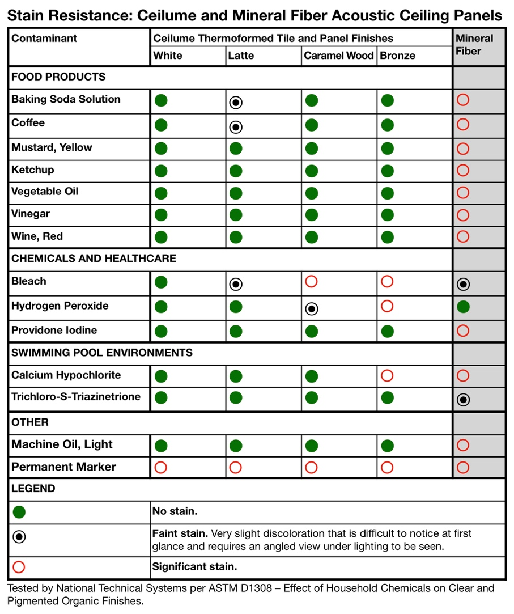
Ceiling panels were tested in accordance with ASTM D1308 – Effect of Household Chemicals on Clear and Pigmented Organic Finishes. A small amount of each contaminant was placed on each specimen panel and allowed to sit for 16 hours before being wiped clean with paper towels and water. Visible stains were sprayed with all-purpose-cleaner, allowed to sit for several minutes, then wiped clean with damp cloth. Results show that Ceilume thermoformed panels resisted most stains while mineral fiber panels were stained by 13 out of 14 test agents.
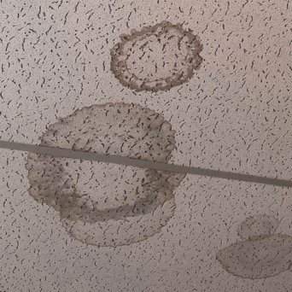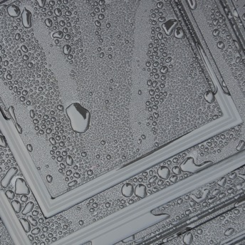
Left: Water can stain mineral fiber panels by leaching contaminants to the surface and supporting the growth of mold. Right: Thermoformed acoustic ceiling panels are impervious to water and water-borne stains. Photo Credits: Ceilume
###

