FOR IMMEDATE RELEASE
February 4, 2019
New Life for Old Ceiling Grids: EZ-On Grid Covers
[Three versions: 260, 150, and 70 words]
[260 Words Version]
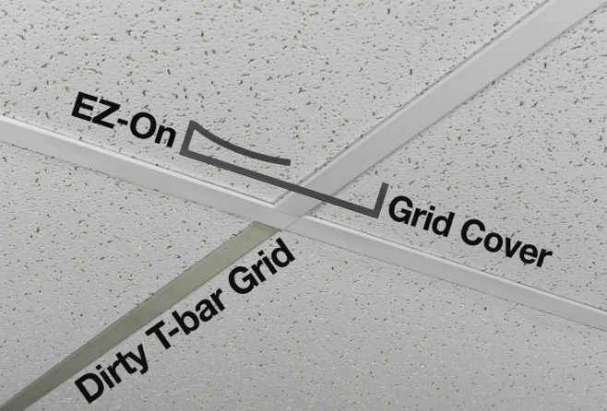
EZ-On™ Grid Covers are the new, easy-to-install solution for suspended ceiling T-bar grids that have become stained, damaged or yellowed with age. Made by the manufacturer of Ceilume ceiling panels, EZ-On Grid Covers are snap-on vinyl strips that cover existing T-bar grids with a brilliant white surface, rejuvenating the appearance of the ceiling system. They make old grids look better-than-new, and present a surface that is durable and easy to maintain.
EZ-On Grid Covers by Ceilume are the easiest way to rejuvenate dirty ceiling grids.
Metal T-bar ceiling grids are durable, but their painted finish is not. The enamel paint discolors over time. It may get damaged during maintenance, and can even rust. A grid that is still completely functional may look terrible.
EZ-On Grid Covers can update a tired ceiling at a faction of the time and cost it would take to paint or replace the grids. The system has only two components – one to cover grid members, the other for perimeter angles – and installs rapidly on virtually all grids with 15/16 in. (1 in. nominal) flanges.
The vinyl strips slide over the T-bar and snap into place easily. No pre-cleaning is needed, no adhesives are applied, and no tools or special training are needed. They can be installed without removing ceiling panels A 400-square foot room could be done by one person in about an hour.
Made from 100% recyclable rigid vinyl in a cool-white, semi-gloss surface, EZ-On grid covers require no maintenance, and are easy to clean with soap and water. Impervious to moisture, they resist mold growth and are non-yellowing.
EZ-On are available direct from the manufacturer at www.ceilume.com/ez-on-ceiling-grid-covers.
- - -
[150 Words Version]
EZ-On™ Grid Covers are the new, easy-to-install solution for suspended ceiling T-bar grids that are stained, damaged or yellowed with age. Made by the manufacturer of Ceilume ceiling panels, EZ-On Grid Covers are snap-on vinyl strips that cover existing T-bars with a cool-white semi-gloss surface, rejuvenating the appearance of the ceiling system.
EZ-On Grid Covers can update a tired ceiling at a faction of the time and cost it would take to paint or replace the grids. They slide into place easily on virtually all grids with 15/16 in. (1 in. nominal) flanges, without pre-cleaning, adhesives, or special tools. A 400-square foot room could be done by one person in about an hour.
Made from 100% recyclable rigid vinyl, EZ-On Grid Covers require no maintenance and clean easily with soap and water. Impervious to moisture, they resist mold growth and are non-yellowing.
EZ-On are available direct from the manufacturer at www.ceilume.com/ez-on-ceiling-grid-covers.
- - -
[70 Words Version]
Ceilume EZ-On™ Grid Covers can rejuvenate ugly T-bar ceiling grids in a snap. They restore virtually all grids with 15/16 in. (1 in. nominal) flanges with a cool-white semi-gloss surface made from 100% recyclable rigid vinyl. EZ-On Grid Covers slide over T-bar grids quickly and easily, are mold resistant, non-yellowing, require no maintenance, and clean easily with soap and water.
EZ-On are available direct from the manufacturer at www.ceilume.com/ez-on-ceiling-grid-covers.
- - -
About Ceilume
About Ceilume: Ceilume is the leading manufacturer of thermoformed ceiling and wall tiles and panels. The company’s roots go back to when “Mid-Century was Modern” and the pioneers of modular ceilings. The family-owned business is located in California’s wine country and occupies a historic apple-packing warehouse. With an eye on the future, Ceilume’s research and development continues to improve interior finish systems to meet changing environmental, performance, and aesthetic needs. For more information, see www.ceilume.com/pro.
Download high resolution photos and Word document: www.ceilume.com/pro/press.cfm
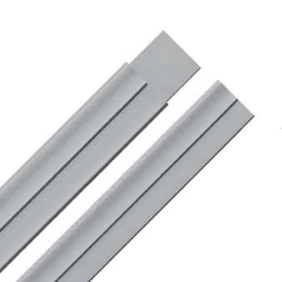
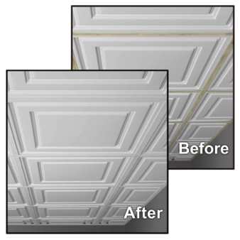
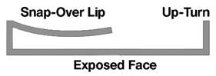
# # #

EZ-On Grid Covers can be used with Ceilume’s thermoformed ceiling panels to transform the appearance of a room.
Cover snaps-over grid and has 1/16th-inch upturns to conceal grid's visible edges.
Covers for T-Bars (top) have out tabs for smooth junctions at grid intersections. A second profile (bottom) trims wall perimeter angles.

