FOR IMMEDATE RELEASE
Drybar: Branding with Style
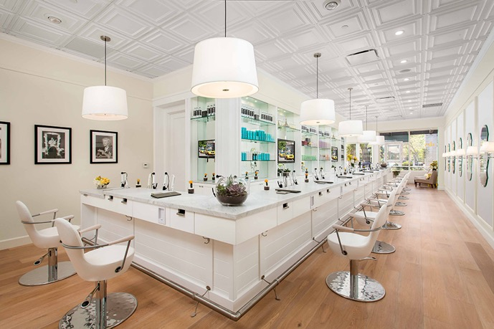
The wildly successful Drybar chain has made their interior design key to their brand, with a white marble bar, a chandelier of yellow blow dryers, and a coffered ceiling of thermoformed Ceilume panels.
Photo Credit: Heitler Houstoun Architects / © Clark Dugger Photography
GRATON, CA, 2019-June-15 -- DryBar, the nationwide chain of hair-styling salons, is a triumph of architectural branding. In the nine years since its first store opened in the Brentwood neighborhood of Los Angeles, CA, DryBar has added about 120 stores across the continent that conform to their signature design aesthetic and offer customers in any location a consistent experience.
The Drybar brand is a service concept expressed as a very particular look. Certain key elements of the design are seen in virtually every store interior (except a few where the look has been modified to fit the context of a special location). These include the bar itself; the white marble countertops; a chandelier made of yellow plastic hair dryers; placement of mirrors where the customer will only see them at the end of the treatment; and a coffered ceiling made of Ceilume thermoformed ceiling panels.
“The real groundbreaking idea of the original Drybar,” explains Josh Heitler, Senior Principal of Heitler Houstoun Architects, “was to break the mold of the salon, to have it look and feel and smell nothing like the typical salon experience.” Heitler Houstoun, New York, NY has designed all of Drybar’s stores from the beginning, refining and tweaking the design, and even fabricating the signature blow dryer chandeliers by hand in their own office. “In 2009, when we were designing the first one, nobody was really sitting at a bar to get a service. Now it’s so ubiquitous, it feels like there’s a bar for everything. But that was the unique idea: you’re getting a service in a new and social way, where you’re sitting at a bar having a glass of wine, watching a movie, perhaps you’ve gone with friends… You’re not staring at yourself in a mirror the whole time. And, there’s the built-in idea of the big reveal, when they turn you around to the mirror at the end. The station itself, all of the dimensions and all materials are standardized across all the stores. The idea is that a customer who’s traveling, at a Drybar anywhere in the country, will find that part of the experience comfortable and familiar.”
That comfortable, familiar experience includes the elegant, coffered ceiling of thermoformed Ceilume panels used in almost all Drybar stores. They were selected for a combination of style and performance.
“The owners and founders gave us what initially sounded like an impossible task,” explains Heitler. “They wanted it to be ‘timeless, but of the moment.’ We’ve used a mix of traditional elements with some more modern elements. Visually, the ceiling panels contribute to the traditional side of the balance. They look like coffered ceilings, which gives texture and interest.”
Heitler points out that style was not the only criterion for the ceiling. “They’re also a very maintainable and cleanable product; that’s important due to hairspray and other styling products. We originally used a different panel, but we quickly changed to Ceilume because the original panels, although they looked similar, were not as easy to maintain and clean. The Ceilume panels have worked for us over the years because they give us the detail and the character we’re looking for, but in a very practical and maintainable way.”
Made from rigid vinyl, they are impervious to water and washable. If it is necessary to remove suspended ceiling panels for access above the ceiling, the panels are lightweight and easy to remove without damaging. Drybar’s ceiling, Ceilume’s Cambridge style, in white, is one of 39 styles, available in 16 colors and custom colors.
The coffered ceiling, complementing the rectangular product shelves and the crisp detailing of the bar, completes the stylish ambience that the founders sought to bring to hair styling. “It is intended to be a positive social experience, such as going to a bar” comments Heitler. “A lot of that comes from the hints you get from the environment. It looks like spaces where you’re used to having fun.”
--------------
About Ceilume: Ceilume is the leading manufacturer of thermoformed ceiling and wall tiles and panels. The company’s roots go back to when “Mid-Century was Modern” and the pioneers of modular ceilings. The family-owned business is located in California’s wine country and occupies a historic apple-packing warehouse. With an eye on the future, Ceilume’s research and development continues to improve interior finish systems to meet changing environmental, performance, and aesthetic needs. For more information, see www.ceilume.com/pro.

High-Resolution Photos and Word Document: www.ceilume.com/pro/press.cfm
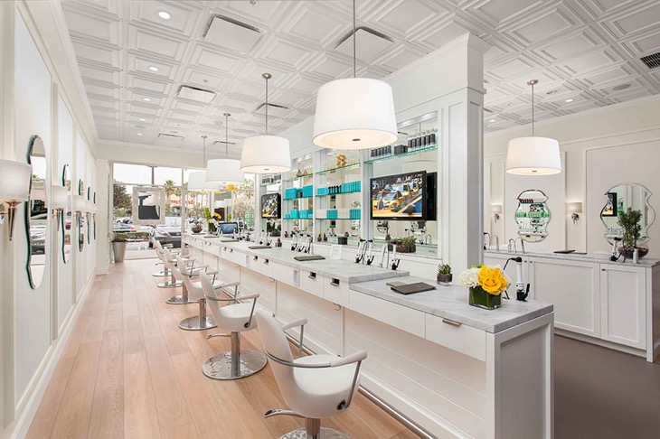
The look, intended to evoke a bar-like social venue instead of a traditional hair salon, blends elements of traditional and contemporary design. Photo Credit: Heitler Houstoun Architects / © Clark Dugger Photography
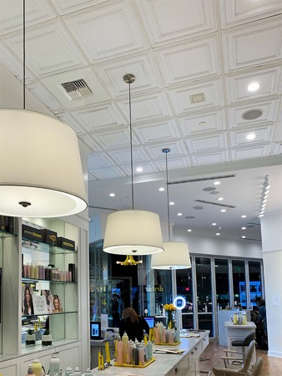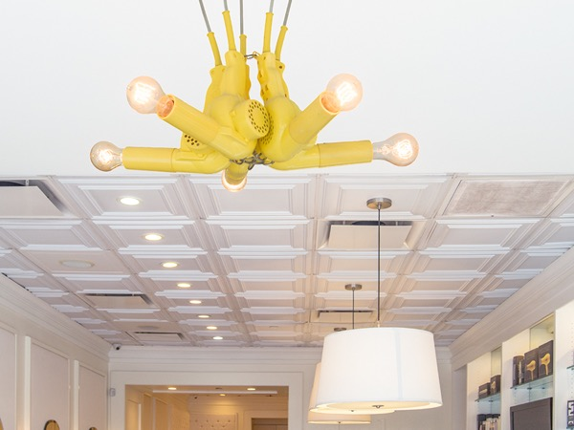
LEFT: Because of the use of sprayed products during Drybar treatments, ceiling panels that can be cleaned easily are a must for Drybar’s finishes. Photo Credit: Ceilume
RIGHT: Every Drybar includes a chandelier made of blow dryers, each one fabricated by the architect’s office. Photo Credit: Steven H. Miller
###

