FOR IMMEDATE RELEASE
Taco Bell Goes Over and Above to Create a More Engaging Interior
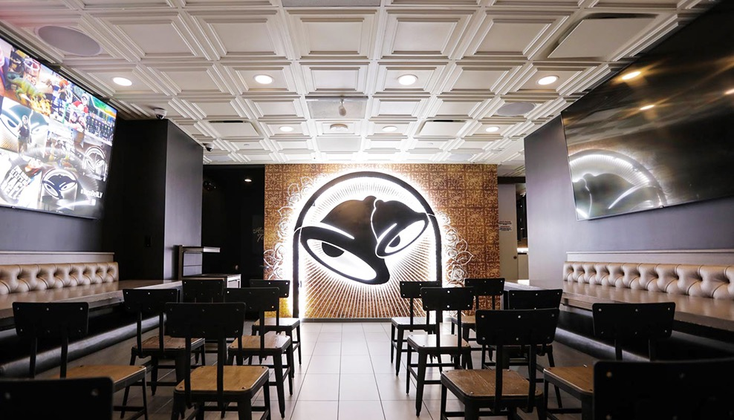
Image courtesy of Taco Bell
Taco Bell’s flagship Cantina on the Las Vegas Strip features a wedding chapel with wedding bells on the walls and an elegant coffered ceiling by Ceilume.
GRATON, CA, 2019-April-23 -- If you want to get married in Vegas, Taco Bell has a place for you. The fast-food giant’s Las Vegas “flagship” Cantina, located in the heart of The Strip, is a world apart from the traditional, tiny Taco Bell drive through. The Cantina is a two-story restaurant with a large central atrium that looks more like a hot dance club than a fast food outlet, and is pumped full of music to match. Upstairs is the Wedding Chapel, a more brightly lit dining room with flat screens on the side walls, and an enormous backlit graphic at the far end of the room with the company’s logo portrayed as wedding bells. The decorative ceiling panels, made by Ceilume, are relatively low and therefore very prominent; a field of elegant white coffers that add notes of formality and elegance, like icing on a wedding cake. The room is available for wedding parties of up to 15 guests, and comes with a sauce-packet bouquet for the walk down the aisle and a 12-pack of tacos.
The Las Vegas Cantina is one of an emerging group of Taco Bell locations that is transforming the customer experience of the international chain. “Taco Bell is removing the ‘one size fits all’ development model of quick service restaurants,” the company explains, “and building unique restaurants with unique features to better serve the many communities in which we operate.”
The new styles, called Urban Inline restaurants and Cantinas (the only difference is that Cantinas serve alcohol), have larger and more architecturally appealing interiors, and no drive through windows. According to Christina Hernandez, a Taco Bell in-house brand architect, these new locations, “focus on bringing customers out of the drive through and inside the restaurant.” They not only have greater seating space than many old Taco Bells, but offer an environment with style and visual interest. They feature “localized designs and artwork, an open kitchen, digital menu boards, and a "Shareable Menu” with unique menu items not found at your regular Taco Bell.”
Taco Bell has debuted four new design concepts. These new restaurant styles are being rolled out across the country, but each was initially launched in Southern California. One architectural enhancement that unifies the four designs are ceilings made of Ceilume thermoformed panels.
The Heritage concept store features warm white walls and a coffered ceiling made with latte- and black-colored Stratford style Ceilume panels. The concept, which also includes timber beams in some stores, takes it inspiration from the Spanish Mission architectural motifs used by earlier generations of the chain’s restaurants.
The Modern Explorer theme also uses the latte- and black-colored panels. The concept is inspired by the farm-to-table movement and features an open kitchen and wood-grained furniture.
California Sol celebrates the active outdoor California lifestyle. They use the same style of Ceilume panels, but in bright white that expresses daylight and blurs the lines between indoor and outdoor.
In the Urban Edge design, black and latte versions of the same ceiling panels are used to create an image that Taco Bell says “is reflective of international high street style and is inspired by timeless design married with cutting edge urban sensibility.”
The thermoformed, rigid vinyl ceiling panels, utilized so extensively by Taco Bell in its new designs, not only complement and contribute to the architectural statement, but are impervious to water, stain resistant, and washable, making them compliant with code requirements for use over food handling areas. Panels are durable, recyclable, and Greenguard Gold certified for indoor air quality, factors that help the firm meet the environmental goals of parent company, YUM! Brands. As Taco Bell continues to roll out these new designs, expect to see more interesting ceilings appearing across the US.
--------------
About Ceilume: Ceilume is the leading manufacturer of thermoformed ceiling and wall tiles and panels. The company’s roots go back to when “Mid-Century was Modern” and the pioneers of modular ceilings. The family-owned business is located in California’s wine country and occupies a historic apple-packing warehouse. With an eye on the future, Ceilume’s research and development continues to improve interior finish systems to meet changing environmental, performance, and aesthetic needs. For more information, see www.ceilume.com/pro.

High Resolution Photos: www.ceilume.com/pro/press.cfm
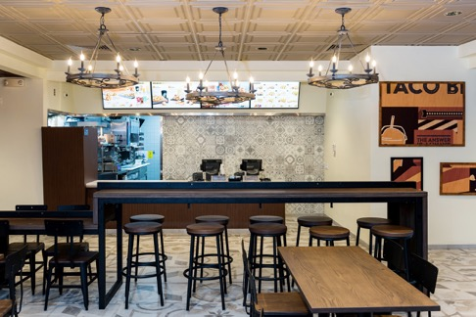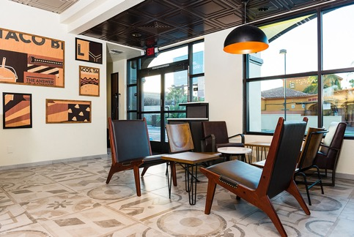
Images by Gamma Commercial Photography
Taco Bell’s new Heritage design has warm white walls, heavy timbers, and coffered ceilings made with Ceilume’s Stratford panels.
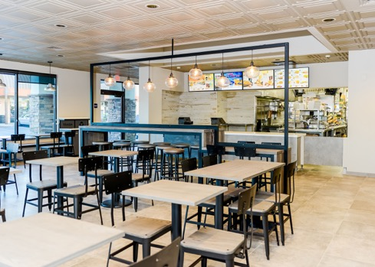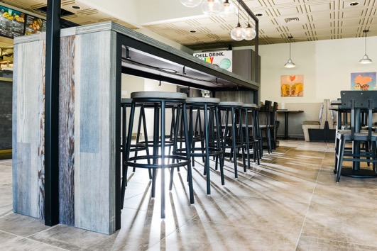
Images by Gamma Commercial Photography
The washable Ceilume ceiling panels extend over the food preparation areas to visually unify the dining areas and exposed kitchens, part of Taco Bell’s Modern Explorer concept.
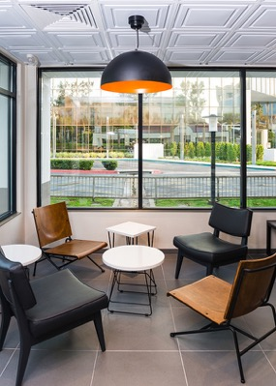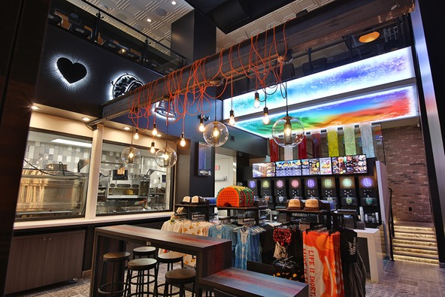
LEFT Image by Gamma Commercial Photography. RIGHT Image courtesy Taco Bell
LEFT: The California Sol restaurants at Taco Bell use bright white Ceilume ceiling panels as part of its indoor-outdoor appeal.
RIGHT: The two-story central space in Taco Bell’s flagship Cantina on the Las Vegas strip has the atmosphere of a dance club. The molded relief in the ceiling panels above the second floor can be clearly seen from below.
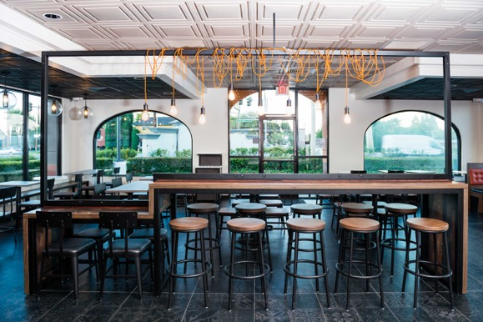
Images by Gamma Commercial Photography
Ceilume ceiling panels are part of the Urban Edge concept that Taco Bell says is, “reflective of international high street style and is inspired by timeless design married with cutting edge urban sensibility.”
###

