New Thermoformed Panels for Walls

A new type of decorative thermoformed panel is now available for use on walls. Thermoformed panels have long been used for ceilings but were not recommended for walls. These new panels from Ceilume, however, have unique, overlapping edges that eliminate the need for trim strips to cover gaps between panels. This makes the panels more robust so they can stand up to light- to medium-duty service as either a wall covering or ceiling tile.

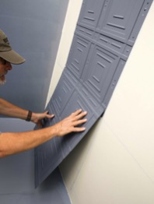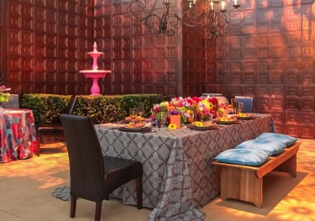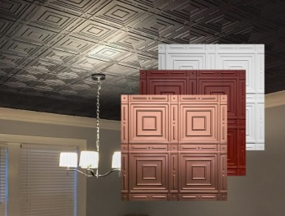
Easy installation Nantucket panels on wall Nantucket panels on ceiling

The nominal 24 x 24-inch rigid vinyl tiles are offered by Ceilume in a variety of colors, faux metal and wood finishes with up to 98% recycled content, and a new random gray with 100% recycled content. The initial wall panel styles, Manchester and Nantucket, have classic motifs that complement many design schemes, and additional styles are planned.

The panels are GreenGuard Gold certified for low VOCs, stain-resistant and washable, and Class A-rated for surface burning characteristics. Lightweight and easy-to-install, they can be glue-applied to drywall or other smooth substrates. Use them to create dramatic and affordable effects on ceilings and accent walls.

# # #

About Ceilume: Ceilume is a family-owned business based in Graton, California. Now in its 50th year, the firm has been in business “Since Midcentury Was Modern.” It has advanced manufacturing equipment, an active R+D program, and the drive to create improved ceiling and wall finishes that meet changing environmental, performance and aesthetic needs. See https://www.ceilume.com/pro.

High resolution photos: Please visit www.ceilume.com/pro/press.cfm to download high-resolution images.

