FOR IMMEDIATE RELEASE
June 25, 2018

A SECOND ACT FOR DECORATIVE WALL AND CEILING PANELS

LAKE VILLA, IILINOIS – After a demanding performance on stage, Ceilume panels now play a starring role in a classroom drama. For the main stage production of Mary Poppins at Lakes Community High School in Lake Villa, Illinois, Ceilume’s thermoformed panels were used as a wainscot to enhance the Edwardian charm of the Banks family’s residence. The panels were still in good condition after the musical, so the school washed and reused them in the ceiling of the black box theater used for drama classes and other theatrical events.

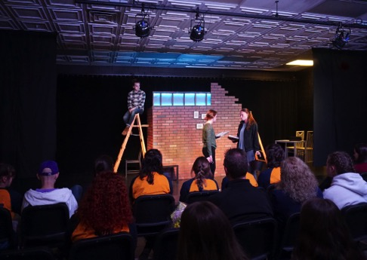
Mary Poppins – Wainscot Drama Classroom – Ceiling

According to Abra Chusid, the school’s drama teacher and theater director, “The dimensional relief of the panels added to the period authenticity of the stage set and enabled our lighting designer to work with shadows and highlights. I am delighted that the panels were strong enough to resist damage during rehearsals and still look great in the classroom. The panels can be cut with ordinary scissors, so the students did the installation themselves and gained additional stagecraft skills.”

Ceilume’s panels are offered in 40 patterns including historic to contemporary styles. In addition to twelve colors plus metal and wood faux finishes, the panels come in three grades of light-transmitting materials, offer enhanced acoustic characteristics, and are GreenGuard Gold certified for indoor air quality. They are Class-A rated for fire safety and can even be installed as drop-out ceilings beneath fire sprinklers, a useful feature if a set requires an on-stage ceiling.

Graduating from school productions, Ceilume’s credits include TV (RuPaul’s Drag Race), the big screen (Star Wars), and many church and special event sets. See www.ceilume.com/pro.

###

ABOUT CEILUME
Ceilume is the leading manufacturer of thermoformed ceiling tiles and panels. The company's predecessor dates from the early 20th Century and was a pioneer in the invention of the modern suspended ceiling. The family-owned business is located in Graton, CA in the heart of California's wine country, and occupies a historic apple-packing warehouse. With an eye on the future, Ceilume has invested in advanced manufacturing equipment and an active R+D program to create improved ceiling and wall finishes to meet changing environmental, performance, and aesthetic expectations. www.ceilume.com

HIGH-RESOLUTION IMAGES
Please visit www.ceilume.com/pro/press.cfm to download high-resolution images.

